N5 Projectiles question
- A package is dropped from a helicopter which is travelling horizontally at 180 ms-1. The package hits the ground 9 s later.
- State the final horizontal speed of the package just before it hits the ground.
- Calculate the final vertical velocity of the package just as it hits the ground.
- When the package hits the ground, where is the helicopter relative to the package?
- Draw a velocity – time graph of the package’s horizontal motion and include relevant numerical values.
- Draw a velocity – time graph of the package’s vertical motion and include all relevant numerical values.
- Calculate the height the package was dropped from.

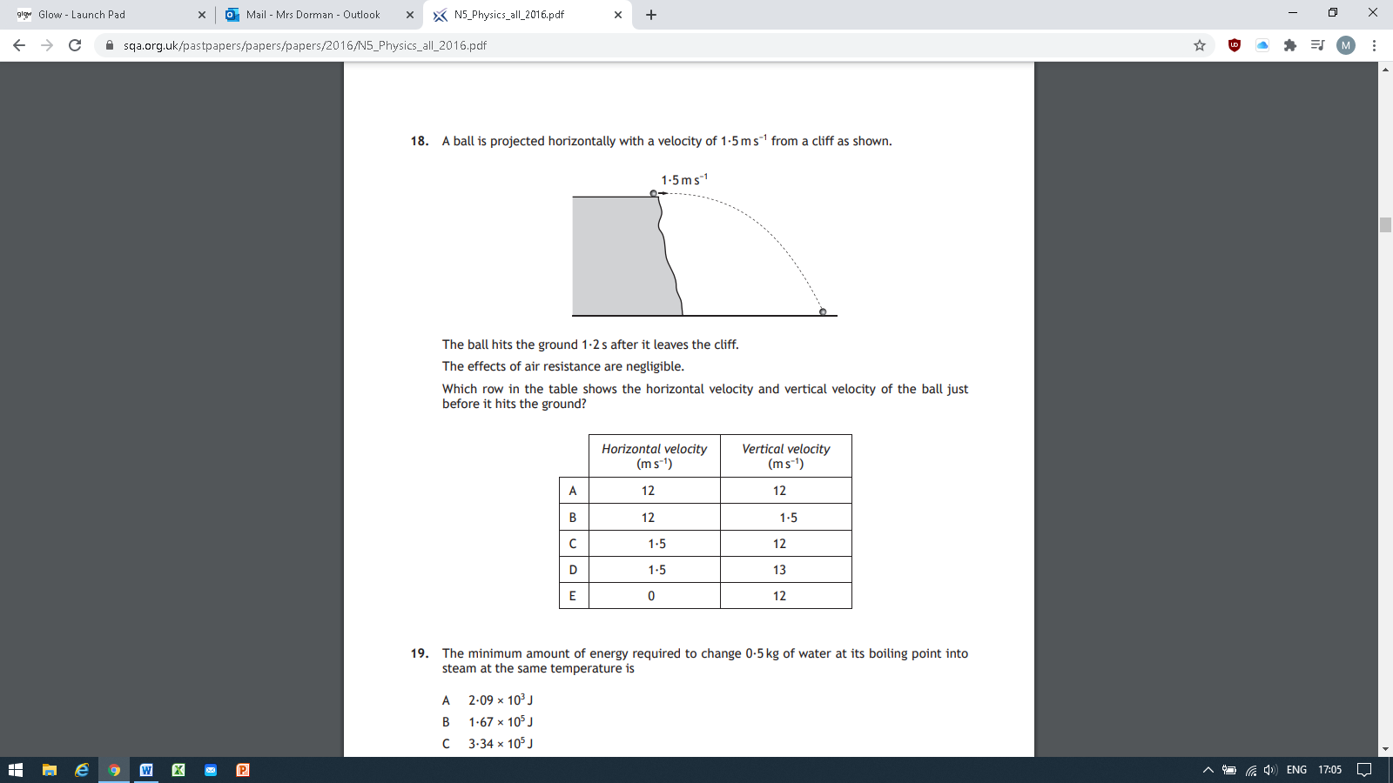
2. Past Paper 2016 Section 1 Q 18 – Please show all working to arrive at answer C

- What information can you obtain from the following diagram? Write down as many facts as you can and show all working for any calculations you do.
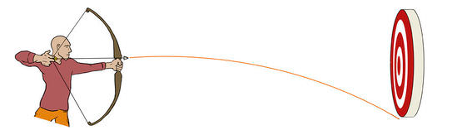
The arrow leaves the bow with a horizontal velocity of 60 ms⁻¹ and the target is 100 metres from the bow.

