Non-Optical Telescopes
Use the information you have learned today and the paragraphs below to answer the four questions on radio and x-ray telescopes.
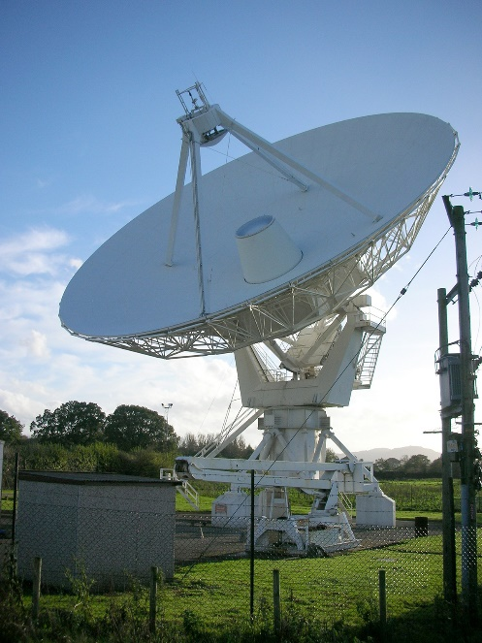

Radio telescopes pick up radio waves instead of light waves. They have a much longer wavelength and provide clear signals. These telescopes need very large aerials and dishes that need to be set up on a large, permanent site. Radio waves are emitted by most bodies in space, so the telescope uses a parabolic dish to reflect the waves to a receiver, which detects and amplifies the signal. They do not rely on light and so can be used 24 hours a day and can also detect gases that are not visible to the human eye.

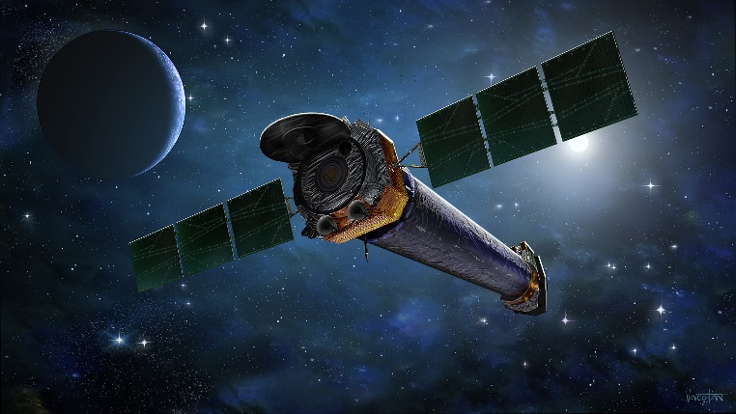

X- ray telescopes can see high temperature explosions in space but can only be used when placed in space because the Earth’s atmosphere will absorb X-rays. Having telescopes in space is expensive to set up, as well as to repair and maintain.

- Radio telescopes are very expensive and need a lot of land to situate them on.
Explain the main benefits of using them.
- Explain why radio telescopes can be used during the day and night, unlike optical telescopes.
- Explain why an X- ray telescope must be placed into space, rather than on Earth.
- Explain the main disadvantages to having telescopes situated in space.

