Emission Spectra

Hydrogen


Helium


Lithium


Neon


Carbon


Sodium



Beryllium

Which elements are present in stars that produce these emission spectra?
Use the Emission Spectra sheet to identify the elements present in each of the following stars.

a)

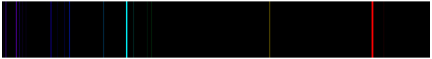

b)
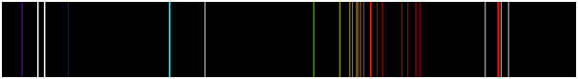

c)
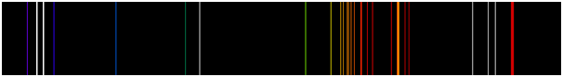

d)

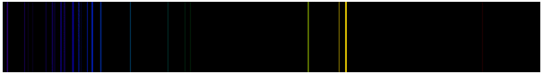

e)
